FORGE FITNESS
Adriaan van der Westhuizen 240436415
T2_Individual

Contents
Business Rules: 2
ERD Diagams: 5

Business Rules:
FORGE FITNESS
Business Rules
1.User Authentication and Registration :
1.1 A new member should provide their ID for verification and create a password.
1.2 Password must meet the systems security requirements (min. length characters).
1.3 A user may only get access to member-only features when their membership is active and verified.
1.4 The system should verify login credentials before giving access.
1.5 User are only allowed to edit their own profile they are logged in with.

2.Membership :
2.1 User must be a registered and verified member of the gym to access membership.
2.2 Memberships are provided in various ways depending on the type of member.(Student , normal citizen, or elderly).
2.3 Memberships automatically expire at the end of the package duration.
2.4 Members may upgrade their package at any time, however downgrading is only permitted at the end of the current billing cycle.
2.5 A member may terminate their membership through their profile settings ; their data will be archived into the database and access will be revoked.

3.Packages :
3.1 Only verified and registered members can buy packages.
3.2 Each package must have a defined price , description and duration .
3.3 A member can only have one package at a time (active package).

4.Courses
4.1 Course content should be evaluated before being published.
4.2 Each course should have a title and description .

5. Personal Trainers Information :
5.1 Trainer profile should be provided with a name , qualification and background.
5.2 Only registered trainers may edit their own profile.
5.3 Trainers profiles are visible to all users. ( registered or not registered)
5.4 Each trainer has a maximum capacity of assigned members to ensure quality of service.
5.5 Trainers and members can communicate only through the system’s internal messaging feature to ensure privacy and record – keeping.

6. Payments and future billings :
6.1 Users pay a registration fee when signing up.
6.2 All package purchases must be recorded in the billing system.
6.3 Users should receive a email when registration was successful.
6.4 Admin may generate and review billing reports.

7. Admin Controls :
7.1 Only administrators are allowed to add and update or even delete members accounts.
7.2 Only administrators may update packages , courses or trainers details.
7.3 Administrators have enhanced privileges on their accounts.
7.4 All changes made by administrators must be logged for audit purposes.

8. System Management
8.1 The System must store all user and membership information in the database.
8.2 The System must back up data regular to prevent risk of losing all data.

ERD Diagams:
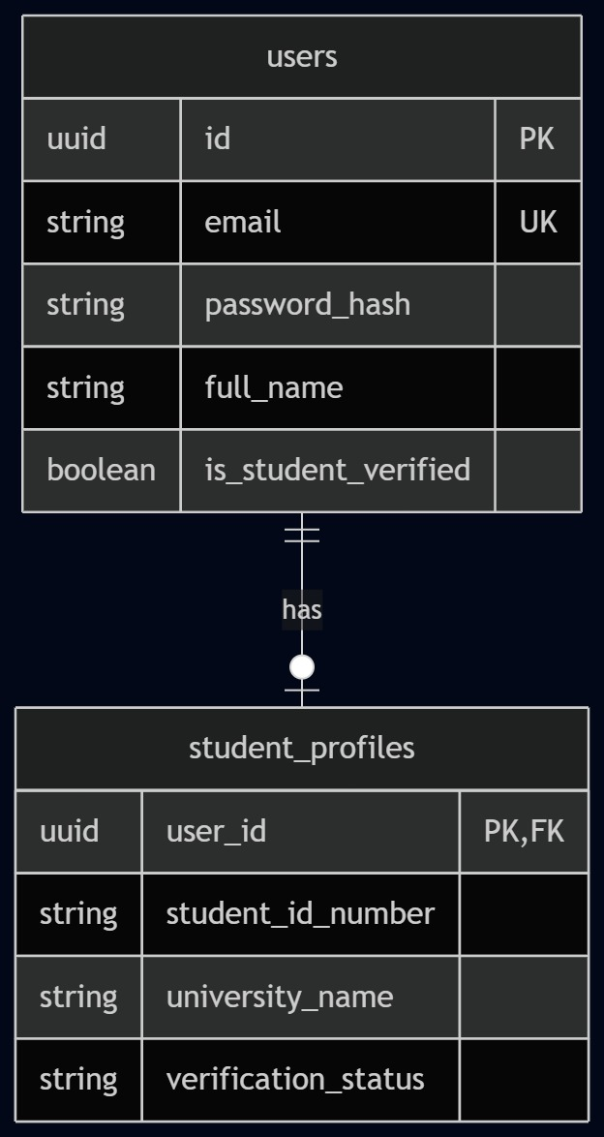
Links to every other module. Users must be logged in to enroll in courses, track plan progress, make transactions, and leave reviews.

Links to Trainers (Module 3). Each trainer is assigned to a location. Locations are displayed on the homepage and about us page.
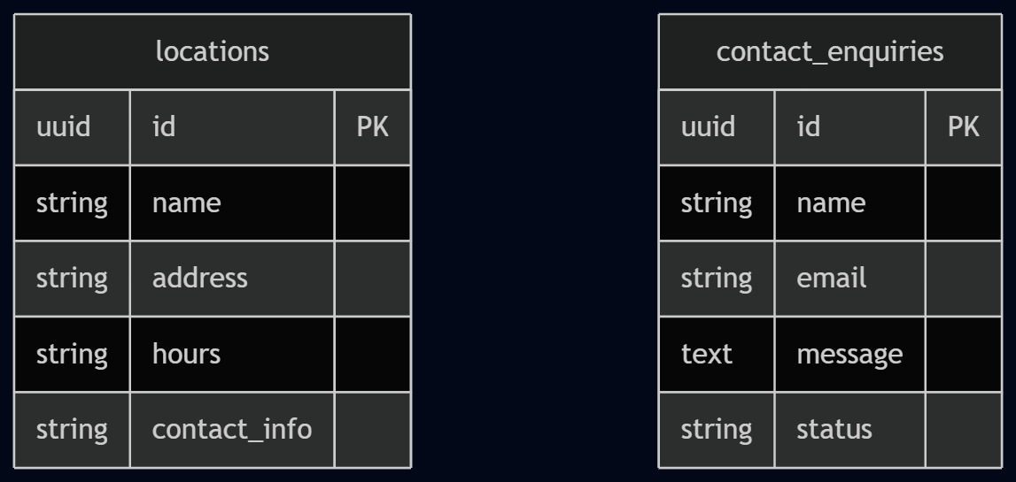

Links to Locations (Module 2) each trainer belongs to a branch. Links to Courses (Module 4) each course is run by a trainer. Links to Users (Module 1) since users write reviews.
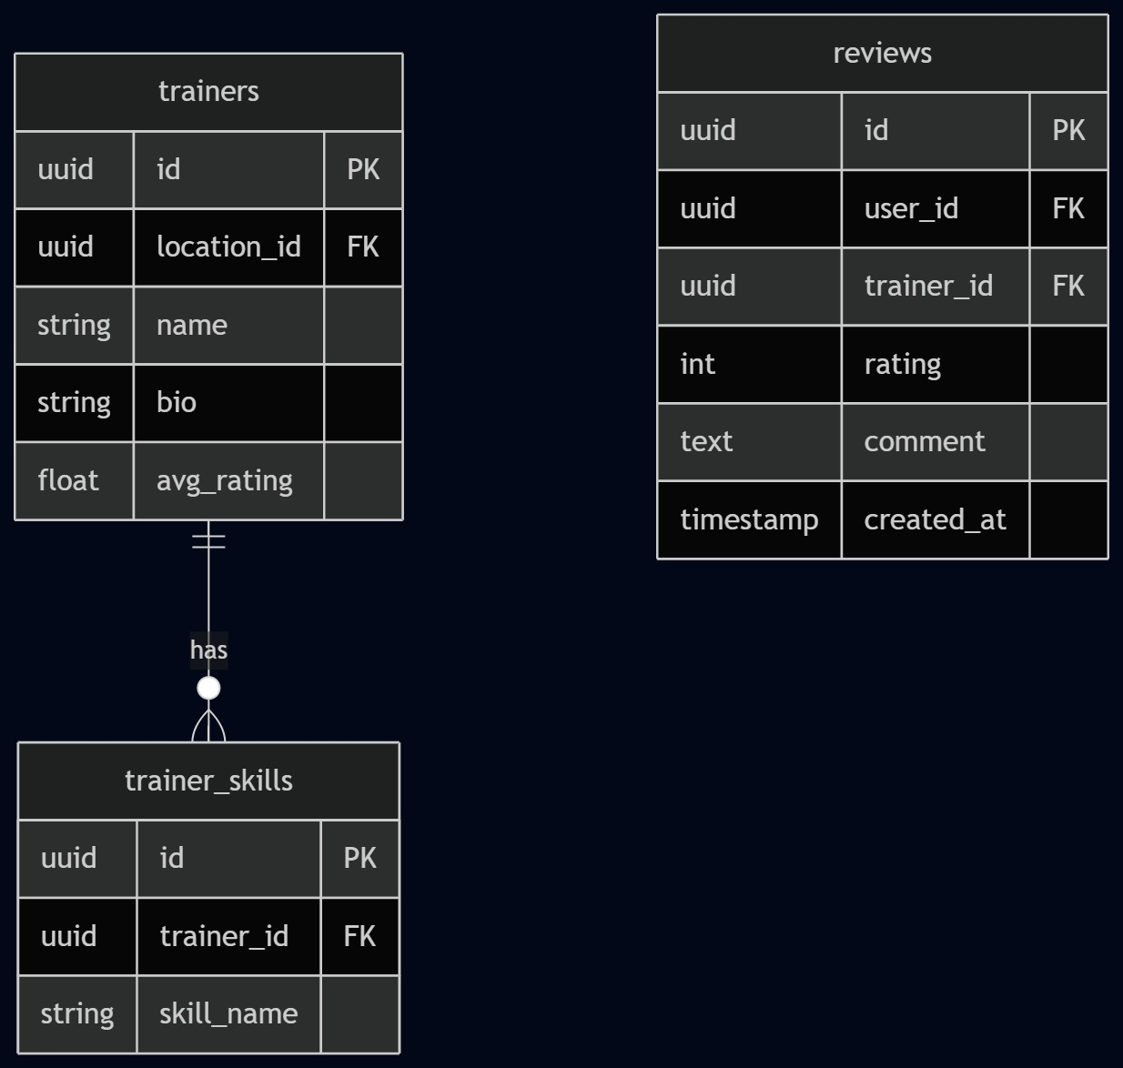
Links to Trainers (Module 3) each course belongs to a trainer. Links to Training Plans (Module 5) courses contain plans. Links to Users (Module 1) since users enroll. Links to Packages (Module 6) because package tier determines course access.
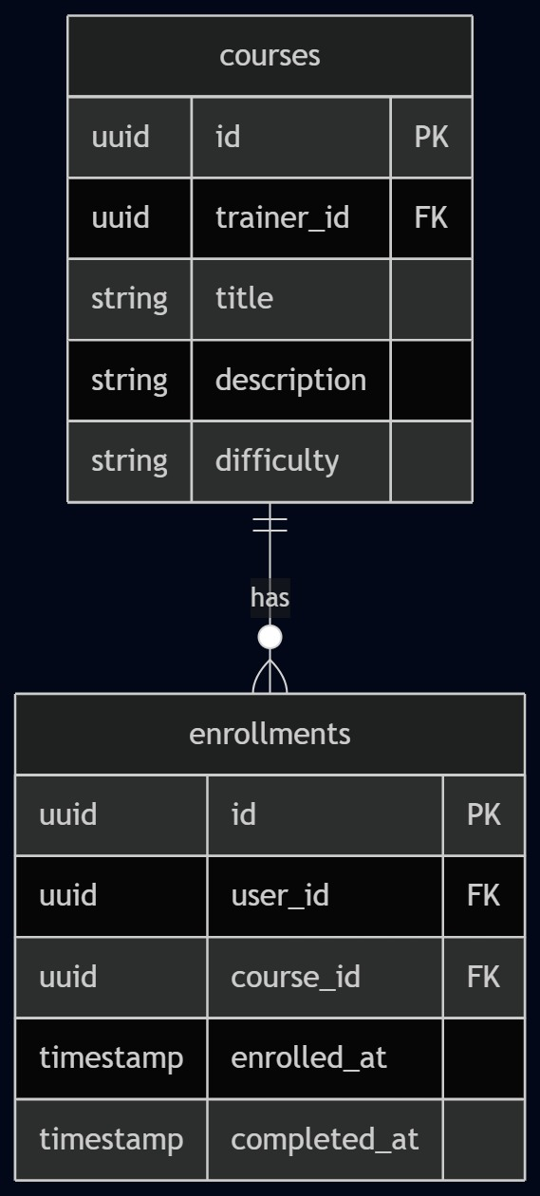
Links to Courses (Module 4) each training plan lives inside a course. Links to Users (Module 1) progress is tracked per user.
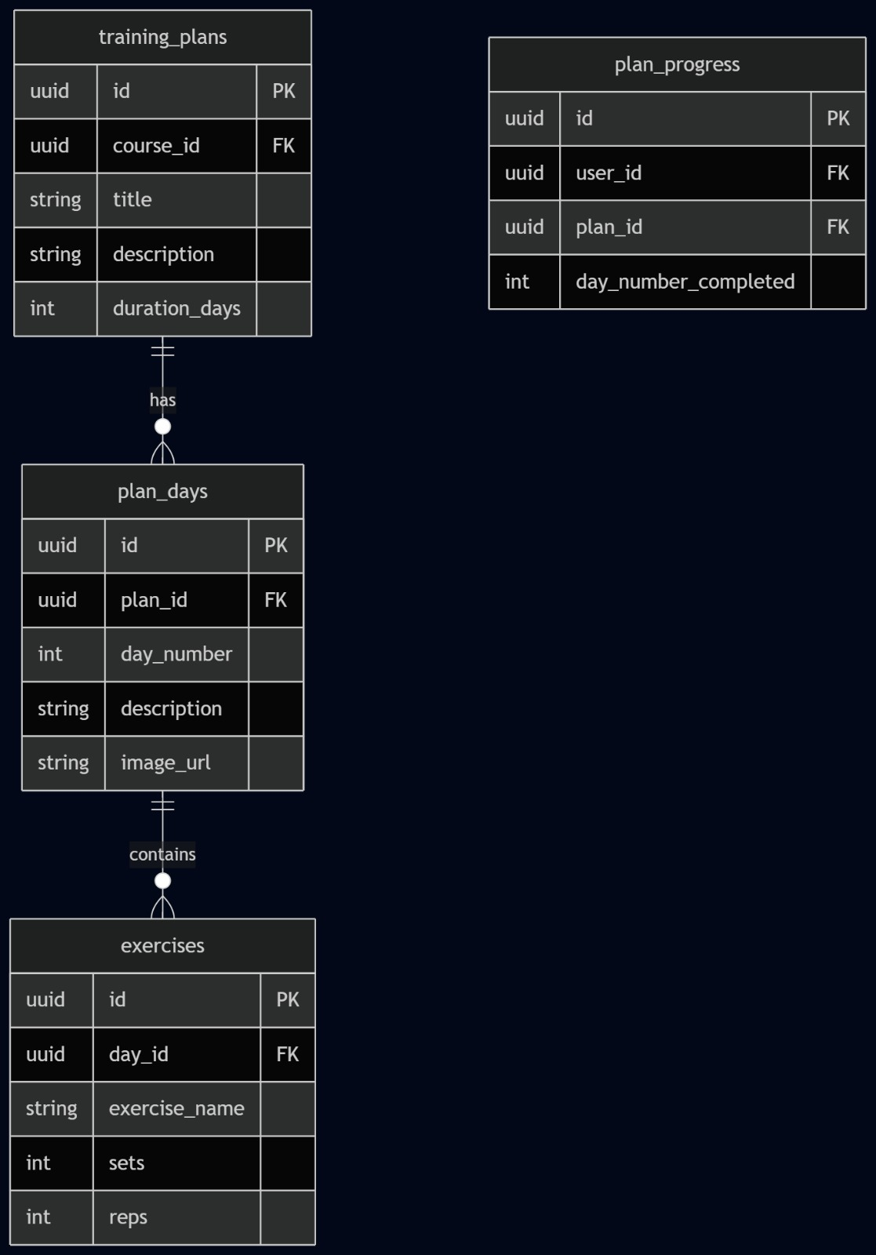
Links to Users (Module 1) a user makes a transaction and their package tier determines what they can access across the whole site.
